**GOVERNMENT COLLEGE OF TECHNOLOGY**

**COIMBATORE**

**(An Autonomous Institution Affiliated to Anna University)**

**COLLEGE CODE-7177**

**BIG DATA ANALYTICS USING IBM CLOUD DATABASES**

**TEAM MEMBERS:**

**SIVAGOVIND G U – 71772114141**

**SOWMIYA P – 71772114143**

**VISHVA SAKTHI M – 71772114150**

**SURITHIKA T - 71772114313**

**SOCIAL MEDIA ANALYSIS:**

Businesses thrive on understanding their customers to the greatest extent possible. The monitoring of people’s online behaviour is therefore becoming important for their success. Organisations are investing in gathering such analytics using big data as a key component for monitoring social media activity, particularly on social networking websites such as Facebook, Twitter and LinkedIn. Social media analytics are the synthesis of the behaviour of internet users. The availability of data on consumers’ web browsing, online shopping behaviour, customers’ feedback and marketing research on social networks allow organisations to gain timely and extensive insights into consumers. Therefore, organisations can focus their market intelligence strategies based on different objectives such as advertising and product launches; publicity and brand management; promoting customer loyalty; providing personalised services to customers; keeping a tab on market trends and competitors; minimising risk; saving cost and business expansion in general.

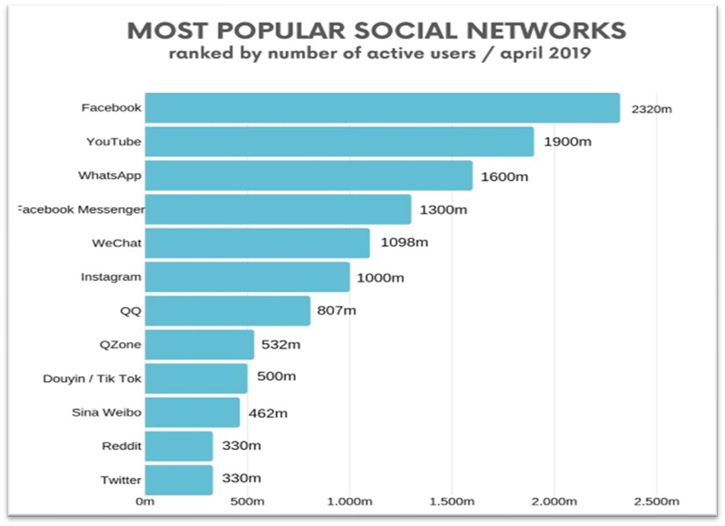

**ALGORITHM USED : K-MEANS CLUSTERING :**

K-Means Clustering is an Unsupervised Machine Learning algorithm, which groups the unlabeled dataset into different clusters. It does this by iteratively finding cluster centroids and assigning data points to the nearest centroid. K-means is commonly used for tasks like customer segmentation and image compression.

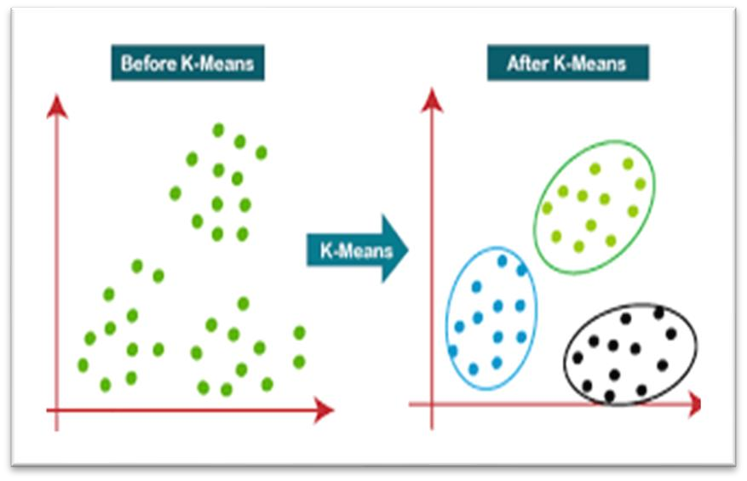

**K-MEANS CLUSTERING ALGORITHM WORKS IN SOCIAL MEDIA ANALYSIS:**

**1.Data Collection:**

* Collect a large volume of social media data using various sources, such as APIs, web scraping, or databases.
* This data could include text, user interactions, and metadata.

1. **Data Preprocessing:**

• Preprocess the collected data to extract relevant features or information.

* + This could involve text cleaning, tokenization, and feature engineering to represent social media content in a numerical format.

1. **Data Storage and Management:** 
   * Store the preprocessed data in IBM Cloud services, such as Cloud Object Storage, making it easily accessible and scalable for big data processing.
2. **IBM Cloud Setup:** 
   * Create an IBM Cloud account and configure the necessary services, such as IBM Watson Studio, which provides a collaborative environment for data analysis and model development.

**5.K-means Clustering Implementation:**

Utilize IBM Watson Studio or open-source tools within IBM Cloud to implement the K-means clustering algorithm.

**Selecting the Tools:**

* + **IBM Watson Studio:** Watson Studio is a powerful tool within IBM Cloud that offers a collaborative environment for data analysis, machine learning, and model development. It provides a user-friendly interface for running the K-means algorithm, making it accessible for data scientists and analysts.
  + **Open-Source Tools:** In addition to Watson Studio, you have the flexibility to use open-source tools, such as Python libraries like Scikit-learn or data science platforms like Jupyter notebooks. These tools offer more customization and control over the Kmeans implementation.

Define the number of clusters (K) based on the nature of your analysis, which may involve user segmentation, content grouping, or sentiment analysis.

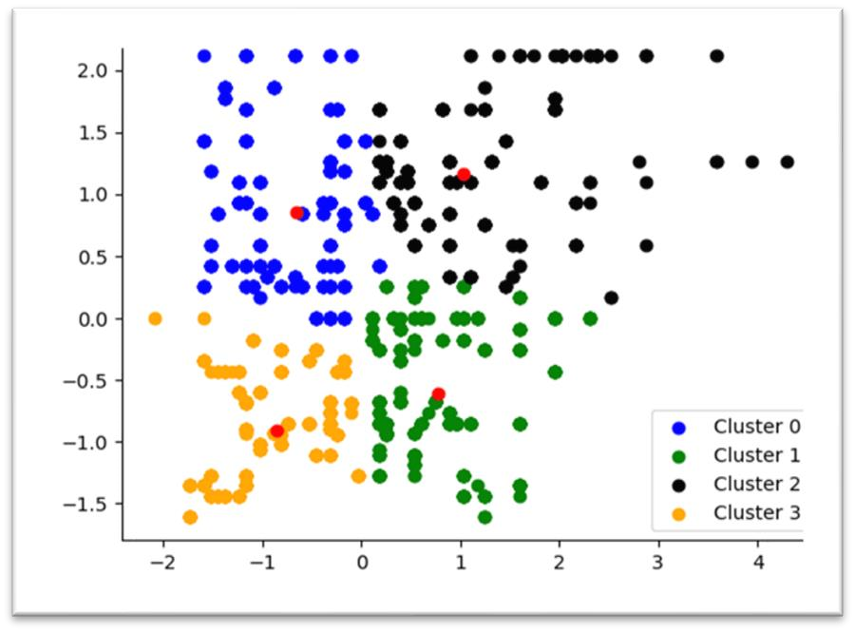

**6.Feature Scaling:**

* + Normalize or scale the features, ensuring that all data points contribute equally to the clustering process, regardless of their original data types.

1. **Clustering Analysis:** 
   * Run the K-means algorithm on the pre processed data, where it iteratively assigns data points to clusters based on the proximity to cluster centroids and recalculates centroids until convergence.

1. **Result Interpretation:** 
   * Analyse the clusters formed by K-means, which could represent different groups of users, types of content, or sentiment categories in the context of social media analysis.

**RECENT TRENDS IN SOCIAL MEDIA ANALYSIS USING BIG DATA ANALYSIS:**

**1.Real-Time Analysis:**

The demand for real-time social media analysis has grown significantly. Brands and organizations want to monitor and respond to social media trends and customer sentiment as they happen. Real-time analysis allows for proactive decision-making and immediate responses.

**2.Image and Video Analysis:**

With the proliferation of visual content on social media platforms like Instagram, TikTok, and Snapchat, analys ing images and videos has become crucial. This involves techniques like image recognition and video sentiment analysis.

**3.Influencer Analysis:**

Identifying and analysing the impact of social media influencers has become a focal point for many brands. Big data analytics is used to assess the reach, engagement, and effectiveness of influencer marketing campaigns.

**4.NLP Advancements:**

Natural Language Processing (NLP) techniques are continuously evolving, enabling more accurate sentiment analysis, entity recognition, and language-specific analysis.

Multilingual analysis and the understanding of regional dialects are also emerging trends.

**5.Social Listening and Social CRM:**

Social listening tools are being integrated with Customer Relationship Management (CRM) systems to provide a holistic view of customer interactions. This allows for personalized responses and better customer engagement.

**6.Emotion Analysis:**

Going beyond simple sentiment analysis, emotion analysis aims to understand the nuanced emotions expressed in social media content. This trend helps in gauging customer satisfaction and reactions more accurately.

**7.Privacy and Ethical Concerns:**

As privacy regulations like GDPR and CCPA gain prominence, analysing social media data while adhering to these regulations is essential. Ensuring ethical data collection and analysis practices is becoming a growing concern.

**8.User-Generated Content for Product Development:**

Companies are increasingly using user-generated content (UGC) on social media for product development and improvements. Analysing user feedback and reviews helps in shaping product features and design.

**9.AI-Powered Chatbots and Customer Support:**

Chatbots and AI-driven customer support on social media platforms are gaining traction. These bots use big data analytics to provide automated but personalized responses to customer inquiries.

**10.Crisis Management and Brand Reputation:**

The ability to monitor and respond to crises on social media is crucial for brand reputation management. Big data analysis aids in tracking and mitigating potential reputation risks.

**11. Customized User Experience:**

Businesses are increasingly personalizing their customer's social media experience using big data analysis. This includes tailoring content, recommendations, and advertisements based on an individual's social media behaviour and preferences.

**CONCLUSION:**

In conclusion, innovation in the realm of social media analysis using big data is a driving force that enables organizations to harness the full potential of the digital landscape. It empowers businesses to uncover valuable insights, adapt to evolving trends, and make data-driven decisions in real-time. As technology and user behaviour continue to evolve, the integration of innovation in social media analysis is not just a choice but a necessity for staying competitive and relevant in the dynamic world of social media. Those who embrace innovation in their data analysis practices will be best positioned to lead, engage their audiences, and succeed in the ever-changing social media landscape.